Customer Success Story CA CENSUS 2020

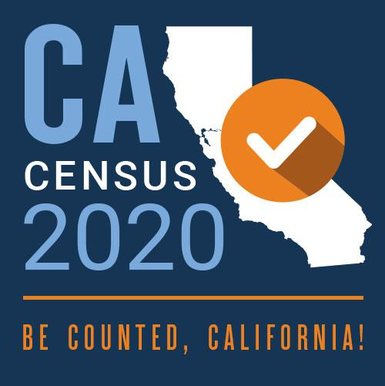

The U.S. Census Bureau is the agency responsible for managing all aspects of the census process including communication, data collection, and reporting of the results.

The chatbot could also be communicated to through SMS/text messaging and Interactive Voice Response (IVR) to ensure it was completely available to Californians with low broadband, no smart phones and with disabilities.

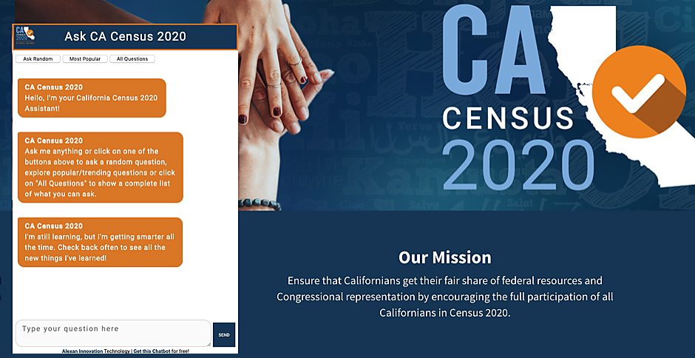*census.ca.gov*

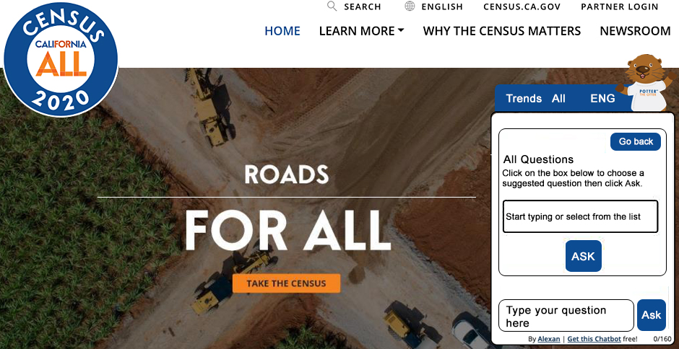

*californiacensus.org*

Key outcomes

* Allowed for the entry of thousands of new census responses.
* Implemented in over 20 city and country websites throughout California.
* Increased accessibility by providing information in multiple languages, including Spanish and Tagalog, as well as Interactive Voice Response for people with disabilities.

Reaching the hard-to-count California Population

The challenge was not only to spread information about the importance of the Census, but to specifically target those residents in California that are traditionally hard to count, especially since the 2020 Census relied heavily on online responses through the Census website. This hard to access population included people that might not have a broadband subscription, or are foreign-born residents, are renters, or individuals living in communal homes or centers, and people living close to or below the poverty line. Because of this, the Census Bureau needed to figure out an attractive way to access these people, many that might only have a phone as their only computer. As a result, Potter the Otter was created.

**Designed, built and maintained by OSaaS**, Potter the Otter was the chatbot implemented by the CA Census bureau to attract online visitors to answer the census. This chatbot provided Californians with hundreds the answers to all of the questions about how you can complete the census, the information gathered, and the importance of being part of the enumeration.

The chatbot was provided to all Cities and Counties throughout California and went live on **census.ca.gov**, **californiacensus.org** (a “Potter the Otter”) as well as 16 other county and city websites, including the City of Los Angeles.

